Figure 1. Prevalence of stunting among under-five-years old children in Kenya (2014)

Source: Authors’ with data from DHS (2014).

Figure 4. Counties by intervention type and nutrition constraint, Kenya (2014-2015)
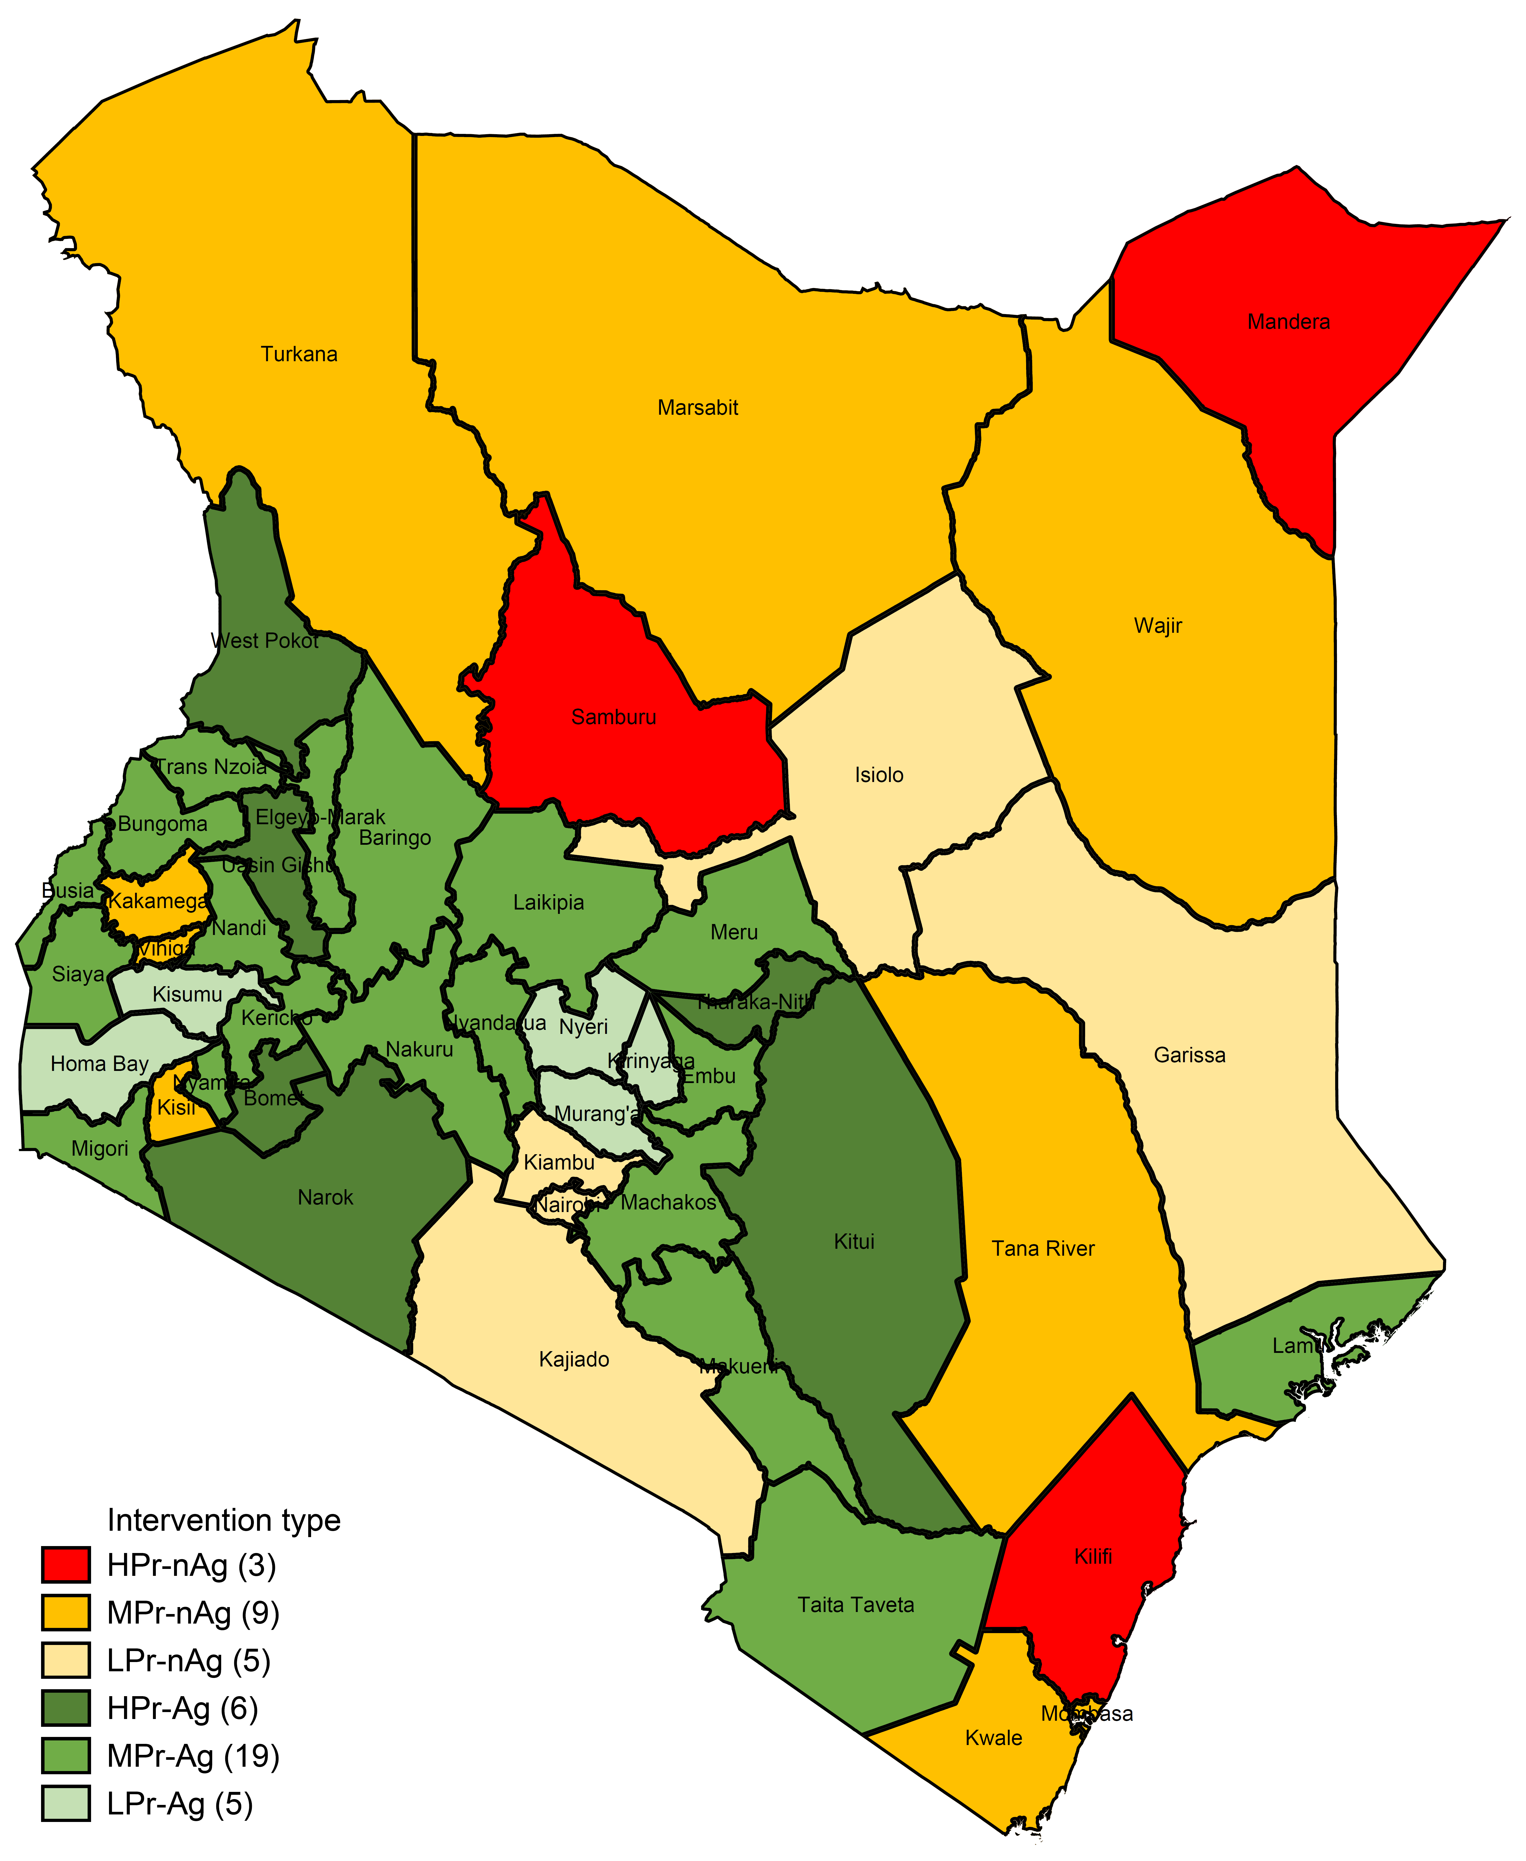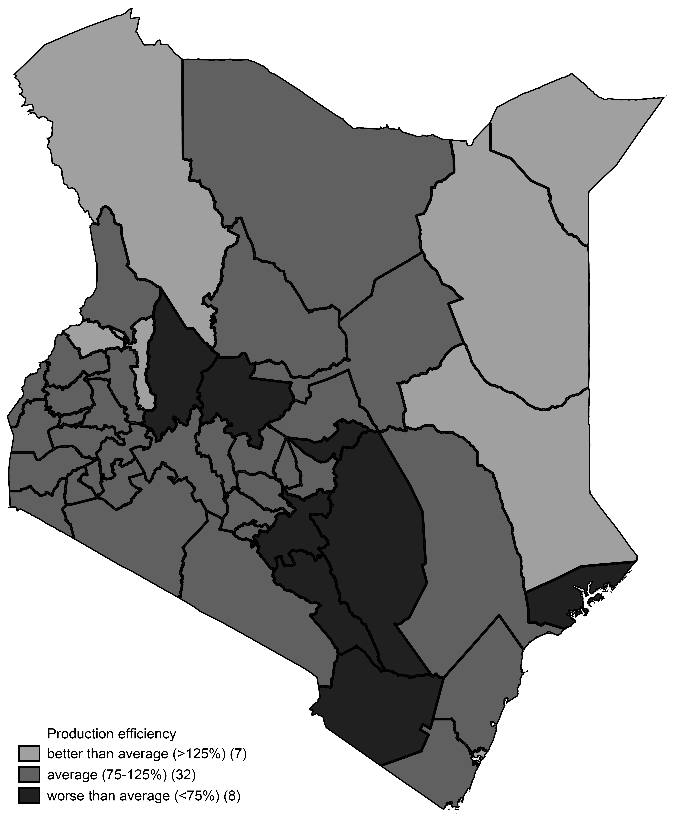
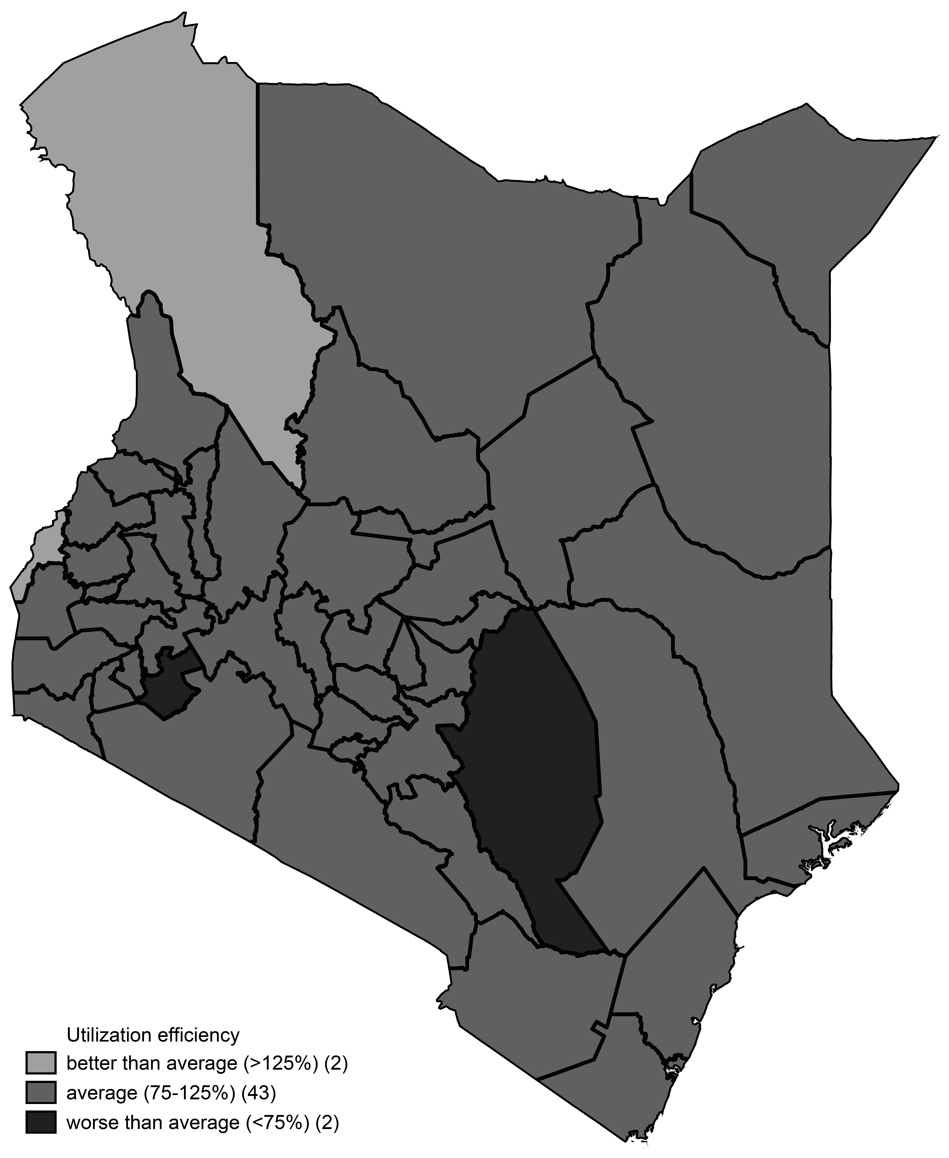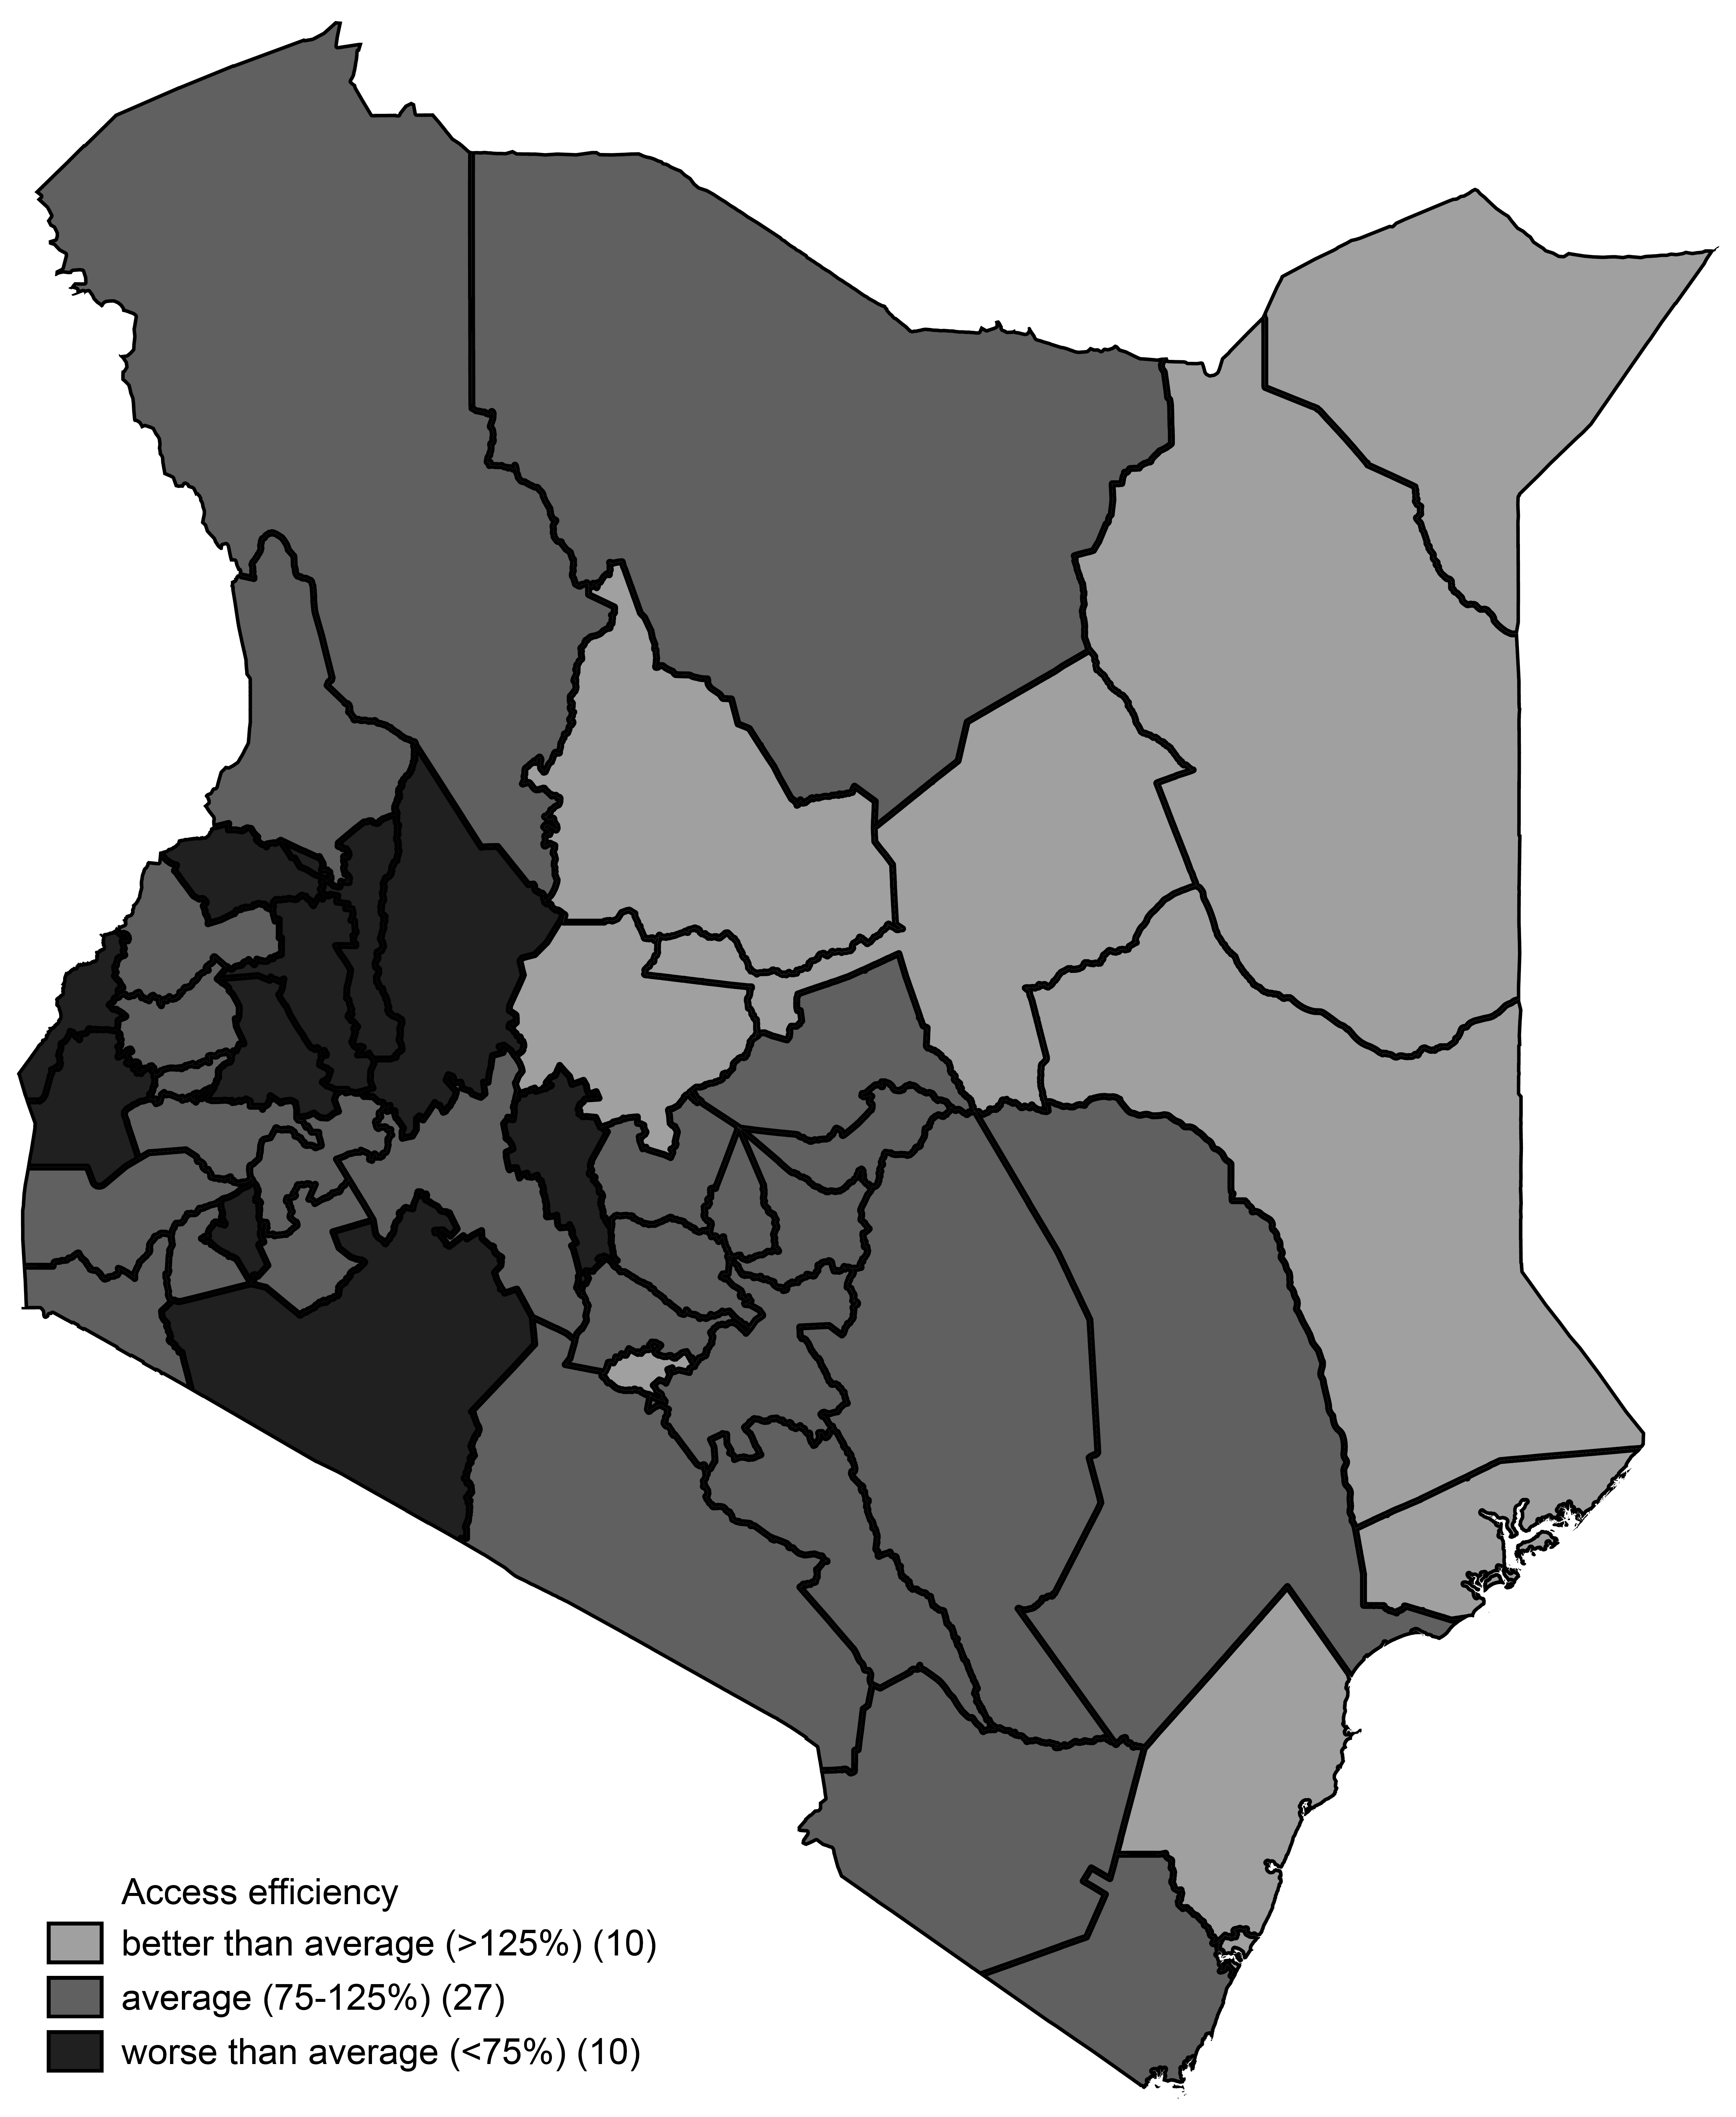
Notes: LPr, MPr, HPr respectively stand for low, medium and high priority counties; and Ag and nAg refer to high and low agricultural potential.
Source: Authors’ with data from Brown de Colstoun et al. (2017); CFSVA (2014); DHS (2014); FAO/Government of Kenya (2018); Hansen et al. (2013); HCD-AFA (2014); KNBS (2016); MOALF (2014); Pekel et al. (2016); Republic of Kenya (2010b); UNEP-WCMC (2018); Xiong et al. (2017).

